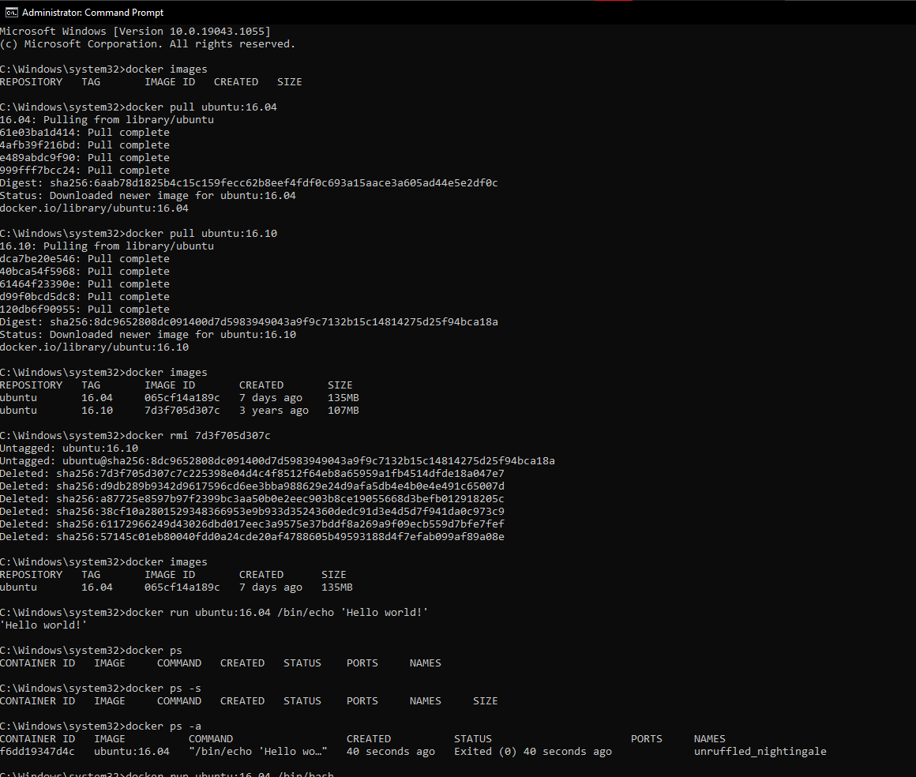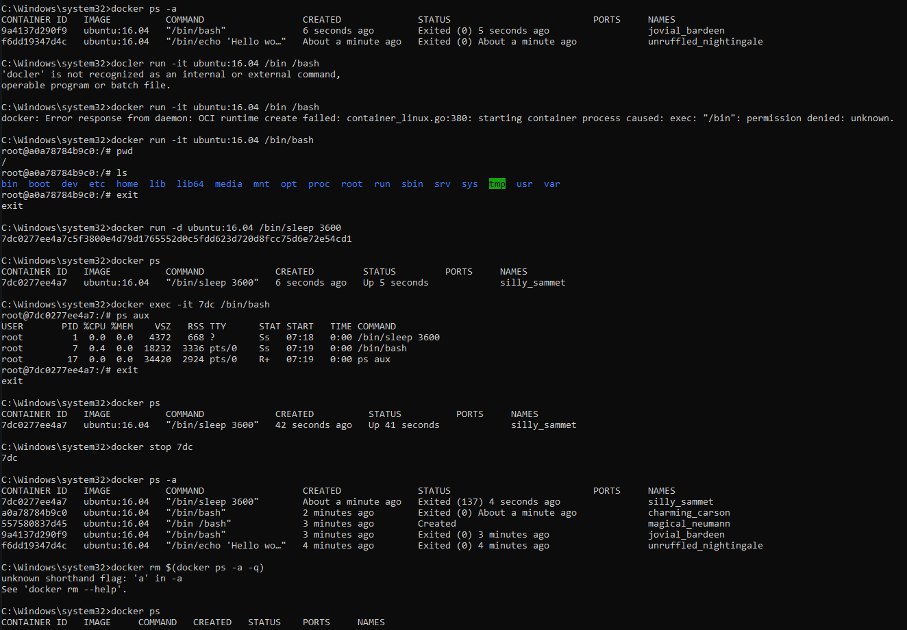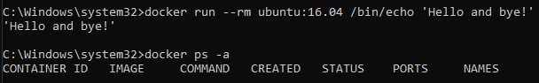

The ‘remove all’ shortcut given in the README did not work for me so I manually deleted it in the docker window =(